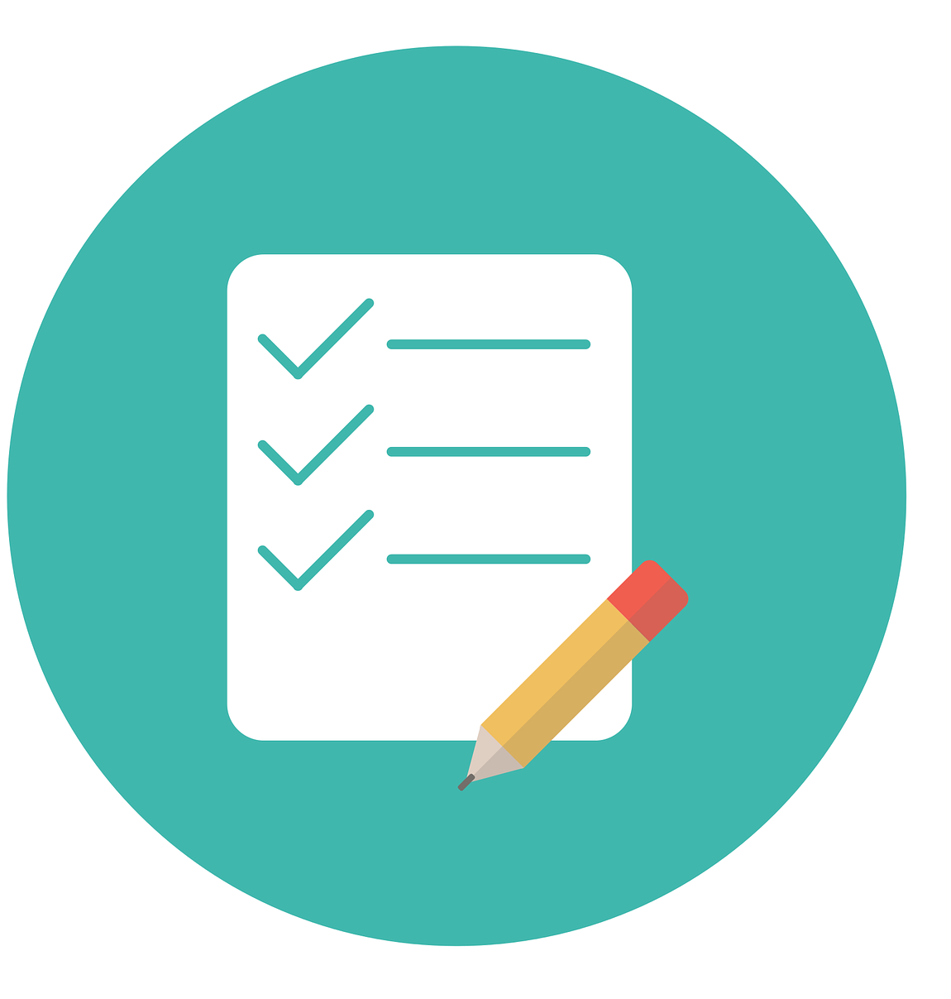

Classroom rules
1. We will sanitize our hands every time we enter the classroom.

2. We will cough and sneeze into our elbows.

3. To keep our friends safe, we will not share pencils or other belongings.

4. To keep our friends safe, we will leave our toys at home.

5. We will leave our books in school at the end of the day.
